Quality Manual
This manual complies with the requirements of the ISO 9001:2015 International Standard.

Teachers ‘N Tools, Inc.
402 Office Park Dr. Suite 104
Birmingham, AL 35223

Table of Contents
1 Introduction 4
2 Management System Approach 5
3 Quality Manual Structure 6
SECTION 1: PLAN 8
4 Context of the Organization 9
4.1 Understanding the organization and its context 9
4.2 Understanding the needs and expectations of interested parties 9
4.3 Determining the scope of the quality management system 9
4.4 Quality management system and its processes 10
5 Leadership 11
5.1 Leadership and commitment 11
5.1.2 Customer focus 12
5.2 Policy 12
5.3 Organizational roles, responsibilities and authorities 12
6 Planning 13
6.1 Actions to address risks and opportunities 13
6.2 Quality objectives and planning to achieve them 13
6.3 Planning of changes 14
7 Support 14
7.1.1 General 14
7.1.2 People 14
7.1.3 Infrastructure 15
7.1.4 Environment for the operation of processes 15
7.1.5.1 Monitoring and measuring resources 15
7.1.5.2 Measurement Traceability 15
7.1.6 Organizational Knowledge 15
7.2 Competence 16
7.3 Awareness 16
7.4 Communication 17
7.5 Documented Information 17
SECTION 2: DO 18
8 Operation 18
8.1 Operational Planning and Control 18
8.2.1 Customer communication 18
8.2.2 Determining the requirements for products and services 19
8.2.3 Review of the requirements for products and services 19
8.2.4 Changes to requirements for products and services 20
8.3 Design and development 20
8.4 Control of externally provided processes, products and services (Purchasing) 20
8.4.2 Type and extent of control 21
8.4.3 Information for external providers 22
8.5.1 Control of production and service provision 22
8.5.2 Identification and traceability 23
8.5.3 Property belonging to customers or external providers 23
8.5.4 Preservation 23
8.5.5 Post-delivery activities 23
8.5.6 Control of changes 24
8.6 Release of products and services 24
8.7 Control of nonconforming process outputs, products and services 24
SECTION 3: CHECK 26
9 Performance Evaluation 26
9.1 Monitoring, measurement, analysis and evaluation 26
9.1.2 Customer satisfaction 27
9.1.3 Analysis and evaluation 27
9.2 Internal audit 27
9.3 Management review 28
SECTION 4: ACT 30
10 Improvement 30
10.1 General 30
10.2 Nonconformity and corrective action 30
10.3 Continual improvement 31

1 Introduction

Our Quality Management System Commitment
As the President of Teachers ‘N Tools, Inc., I am committed to the quality management system, taking full accountability, and supporting other roles of leadership. Management uses the process approach and risk-based thinking to ensure the management system is integrated into our business processes to achieve intended results.
I am committed to provide the resources and training needed to ensure an effective quality management system that is necessary for our success and improvement. We provide a work environment that allows our employees to be successful in meeting our customers’ needs.
The Quality Policy is established to be the driving force behind our quality management system, and I will continue to ensure that it remains compatible with the context and strategic direction of our organization.

Cynthia Lowery
Cynthia Lowery
Teachers ‘N Tools, Inc.

Quality Policy
Teachers ‘N Tools

Teachers ‘N Tools, Inc. is committed to:
Supplying quality products on-time
Providing excellent customer service by understanding and knowing our customers well
Enhancing customer satisfaction
Continuously improving our quality management system
Satisfying all applicable requirements.

2 Management System Approach
Our approach to our quality management system is based on the Plan, Do, Check, Act cycle (PDCA). The basis of our business beliefs is represented in three pillars:

Customer Focus
Our customers are the reason we exist. We aim to meet or exceed their needs and expectations to make them successful. We will even try to anticipate their needs and introduce solutions they’ve not seen before in the spirit of true partnership. Our success depends upon our customers’ success.

Process Approach
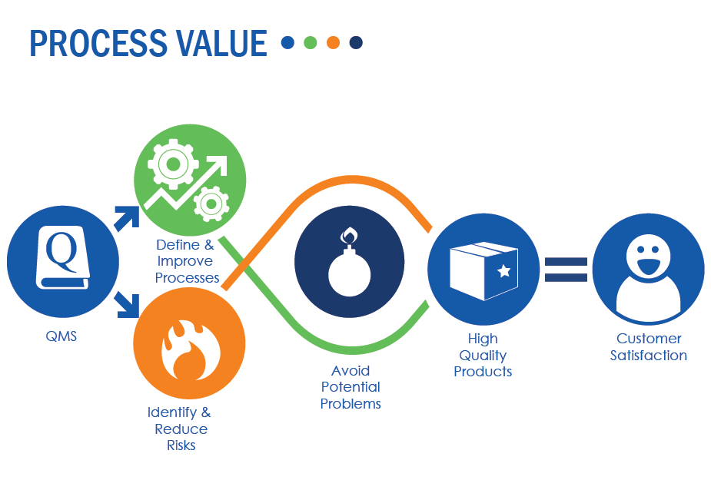
To deliver on our commitment to total customer focus we constantly work on our internal processes to maximize their effectiveness and efficiency. We recognize that it takes countless individual activities to deliver our products and services and that the process approach ties them all together. Our business is a process that transforms several inputs (customer requirements, resources, skilled employees, etc.) into an output that meets our customer’s needs. Within our business are several key processes that make it all work. Our processes are dependent upon one another and individually need continual attention and improvement. We are constantly challenging ourselves to refine and change how we do things to reduce the time it takes to get something done with the least errors. When errors do occur, we use them as opportunities to learn and improve. We are never satisfied with how things are working now and strive to raise our game every day.

Risk-based Thinking
Looking ahead to anticipate what could happen is the reason we employ risk-based thinking throughout our organization. At several points in our process we purposely stop and ask two probing questions:
- “What could go wrong?”
- “Is there a way to improve?”
This perspective of constantly watching for risks and opportunities leads us to action which we carefully manage to ensure timely implementation and effective results. This gives us an attitude of being proactive to take advantage of every opportunity to improve.
We intend these three basic beliefs to cause our customers to stand up and take notice the difference we provide to them on a daily basis. Our quality management system described in this Quality Manual has been carefully crafted to make these three pillars a real part of what makes us work.

3 Quality Manual Structure
This Quality Manual is presented in a PDCA manner and describes our approach to the requirements of ISO 9001:2015. The manual is divided into four sections with all applicable sub-clauses represented in each section as below:
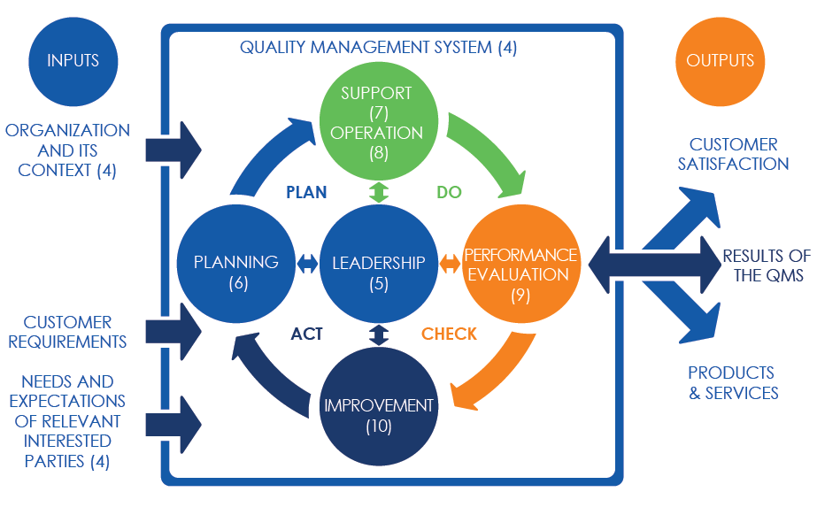

NOTE: In the sections that follow, Bold Blue Text refers to related documentation where additional documentation is maintained and/or records are retained.
SECTION 1: PLAN

With an ever-changing world we are faced with new challenges on a continuing basis. The issues, changes and trends within our industry and the broader economy present us with risks and opportunities from cultural, technological, competitive, regulatory, market, economic and social factors. Not only can these factors affect our business, but there are also other interested parties and organizations that we deal with on a day-to-day basis and these present additional requirements that we must account for.
All of these factors may affect our business negatively (risks) or positively (opportunities). The risks may be relevant to us, and have the potential to affect our business or our customers in a negative way. These aspects of our business environment may also create opportunities for us to improve our organization or take advantage of expanded current or new business ventures.
Planning other aspects of our organization is also very important. Our planning process also includes people, their knowledge and training, infrastructure, environment, documented information, and communication. All planning efforts are structured, include decision-makers, and are documented when required.
Our extensive planning process puts us in the best position possible to forecast these challenges and take actions when necessary. It also establishes the needed foundations for us to provide our products and services.

4 Context of the Organization

4.1 Understanding the organization and its context
Requirement: Determine the external and internal issues that are relevant to the purpose and strategic direction and that affect the ability to achieve the intended result(s) of the quality management system.
Our Approach: Issues (4.1) stemming from trends and changes in our industry may affect our business purpose and strategic direction. Those that present risks and/or opportunities are initially addressed by top management, then monitored and reviewed on an annual basis by our QMS Plan review which occurs during Management Review.

4.2 Understanding the needs and expectations of interested parties
Requirement: Determine the interested parties, and their requirements that are relevant to the quality management system.
Our Approach: Requirements from interested parties (4.2) that impact our ability to meet customer and applicable statutory and regulatory requirements may present risks and/or opportunities. These are reviewed to determine relevance and necessary actions. Subsequently, they are also monitored and reviewed on an annual basis by our QMS Plan review.

4.3 Determining the scope of the quality management system
Requirement: Determine the boundaries and applicability of the quality management system to establish the scope, considering:
- external and internal issues;
- requirements of relevant interested parties;
- products and services.
The scope is available and maintained as documented information stating the:
- products and services covered by the quality management system;
- justification for any instance where a requirement of ISO 9001 cannot be applied.
Our Approach: The contextual issues and interested party requirements are considered to determine the scope (4.3) of our quality management system:
In light of these external and internal issues and requirements, we have established the scope of our quality management system as:
Scope

This quality management system pertains to processes relating to: all aspects of Teachers ‘N Tools, Inc. that are applicable, including the distribution and support services of educational resources for the education industry

The following requirements do not apply;
7.1.5.2 Measurement Traceability
Justification: Teachers ‘N Tools) does not use any equipment to monitor and measure processes for products or services delivered to the customer.
8.3 Design and Development
Justification: Teachers ‘N Tools does not design or develop products for our customers.
8.5.3 Property Belonging to Customer
Justification: Teachers ‘N Tools does not handle property belonging to customers.

4.4 Quality management system and its processes
Requirement: Establish, implement, maintain and continually improve the quality management system, including the processes needed and their interactions.
For the processes needed, determine:
- the inputs required and the outputs expected;
- their sequence and interaction;
- the criteria, methods, including monitoring, measurements and related performance indicators needed to ensure their effective operation, and control;
- the resources needed and their availability;
- the assignment of the responsibilities and authorities;
- the risks and opportunities, and plan and implement the appropriate actions to address them;
- the evaluation and, if needed, the changes to processes to ensure that they achieve intended results;
- and improvement.
Our Approach: The processes (4.4) needed to achieve intended outcomes, results and to continually improve our quality management system are identified on the QMS Plan, and are maintained on Process Plans, and reviewed during Management Review.

5 Leadership

5.1 Leadership and commitment
Requirement: Demonstrate leadership and commitment with respect to the quality management system by:
- taking accountability of its effectiveness;
- establishing objectives that are compatible with the context and strategic direction;
- ensuring that it is communicated, understood and applied;
- integrated the QMS requirements into business processes;
- promoting the use of the process approach and risk-based thinking;
- ensuring that the resources needed are available;
- communicating its importance and conforming to its requirements;
- achieving intended results;
- engaging, directing and supporting people to contribute to the QMS;
- promoting improvement;
- supporting other relevant management roles to demonstrate their leadership as it applies to their areas of responsibility.
Our Approach: Our top management holds the ultimate responsibility for the quality management system. Our top management is dedicated and committed (5.1) to ensuring that our quality management system is effective, understood and improved.
Top management includes the following members:
- CFO*
- President
- Management Representative*

5.1.2 Customer focus
Requirement: Demonstrate leadership and commitment with respect to customer focus by ensuring that:
- applicable requirements are determined, understood and consistently and met;
- risks and opportunities that can affect conformity of products; services and enhancement of customer satisfaction are determined and addressed;
- focus on enhancing customer satisfaction is maintained.
Our Approach: Top management demonstrates leadership and commitment to ensure that all applicable requirements are met, risks and opportunities are addressed, and maintains the focus on customer satisfaction (5.1.2) through our QMS Plan, Process Plans and Quality Policy.

5.2 Policy
Requirement: Establish, implement and maintain a quality policy that:
- is appropriate to the purpose and context and supports the strategic direction;
- provides a framework for setting quality objectives;
- includes a commitment to satisfy applicable requirements;
- includes a commitment to continual improvement of the QMS.
- is available and maintained;
- is communicated, understood and applied;
- is available to relevant interested parties.
Our Approach: The top-level requirement that directs our entire quality management system is our Quality Policy. The quality policy (5.2) is maintained, available, communicated, reviewed annually during Management Review.

5.3 Organizational roles, responsibilities and authorities
Requirement: Ensure that the responsibilities and authorities for relevant roles are assigned, communicated and understood.
Assign quality management system responsibilities and authority for:
- ensuring that it conforms to the requirements of ISO 9001:2015;
- ensuring that processes are delivering their intended outputs;
- reporting on its performance, and opportunities for improvement, to top management;
- ensuring the promotion of customer focus;
- ensuring that its integrity is maintained when changes are planned and implemented.
Our Approach: Responsibilities and authorities (5.3) for our process owners are assigned, communicated and understood on our Process Plans. The CFO will assume the functions and serve as the Management Representative of our QMS.

6 Planning

6.1 Actions to address risks and opportunities
Requirement: When planning for the QMS, consider the issues (4.1) and the requirements (4.2) and determine the risks and opportunities that need to be addressed to:
- assure that the QMS can achieve its intended result(s);
- enhance desirable effects;
- prevent, or reduce, undesired effects;
- achieve improvement.
Plan:
- actions to address these risks and opportunities;
- how to:
  - integrate and implement the actions into our processes;
  - evaluate their effectiveness.
Our Approach: We address the risks and opportunities (6.1) identified in the QMS Plan and Process Plans, as well as other situations through the use of the Action Item Form or Management Review Meeting Minutes.
The actions will be integrated into our quality management system process and will be evaluated for effectiveness during reviews.

6.2 Quality objectives and planning to achieve them
Requirement: Establish objectives at relevant functions, levels and processes that:
- are consistent with the quality policy,
- are measurable;
- take into account applicable requirements;
- are relevant to conformity of products and services and the enhancement of customer satisfaction;
- are monitored;
- are communicated;
- are updated as appropriate.
Retain documented information on the quality objectives.
Our Approach: We establish objectives (6.2) at relevant functions, levels, and processes, and have plans to achieve them on our Measurement Plans. The results of these objectives and plans are reviewed annually and retained on the Management Review Minutes.

6.3 Planning of changes
Requirement: Where needed, carry out changes in a planned manner considering:
- the purpose of the change and any of its potential consequences;
- the integrity of the quality management system;
- the availability of resources;
- the allocation or reallocation of responsibilities and authorities.
Our Approach: Changes (6.3) that are needed are planned and carried out carefully considering the consequences, the integrity of our QMS, resources and associated responsibilities. The changes are managed and are recorded in the Management Review Minutes.

7 Support

7.1.1 General
Requirement: Determine and provide resources needed for maintenance and continual improvement of the QMS considering:
- capabilities, constraints and existing resources;
- needs from external providers.
Our Approach: During our Management Reviews, our top management discusses all internal and externally provided resources needed (7.1.1) for maintenance and continual improvement of our quality management system, and ensures that they are provided.

7.1.2 People
Requirement: Determine and provide the people necessary to effectively implement the QMS and for the operation and control of processes.
Our Approach: During our Management Reviews, our top management determines the persons necessary (7.1.2) for the effective implementation of our QMS and for the operation and control of our processes, and ensures that the resources are provided.

7.1.3 Infrastructure
Requirement: Provide and maintain the infrastructure for the operation of processes and conformity of products and services.
Our Approach: To ensure that our infrastructure resources remain adequate, they are reviewed and discussed during Management Reviews.

7.1.4 Environment for the operation of processes
Requirement: Provide and maintain the environment necessary for the operation of processes and to achieve conformity of products and services.
Our Approach: Our top management ensures that our work environment (7.1.4) is sufficient to achieve conformity of our products and services as discussed during Management Reviews.

7.1.5.1 Monitoring and measuring resources
Requirement: Provide the resources needed to ensure results when monitoring and measuring is used to verify conformity of products and services.
Our Approach: We have determined, and provide the resources needed to monitor and measure (7.1.5.1) our products and services to ensure that they continue to meet requirements and specifications.
We ensure these resources are:
- suitable for the specific type of monitoring and measurement activities;
- maintained to ensure fitness for purpose.
This is documented in the Measurement Plans.

7.1.5.2 Measurement Traceability
Exclusion, see 4.3 above.

7.1.6 Organizational Knowledge
Requirement: Determine the knowledge necessary for the operation of processes and to achieve conformity of products and services. Maintain this knowledge and, make it available to the extent necessary.
When addressing changing needs and trends, consider current knowledge and determine how to acquire or access the necessary additional knowledge and required updates.
Our Approach: All current knowledge (7.1.6) sources, requirements, changes, needs and trends are determined by top management, maintained and discussed during Management Reviews.

7.2 Competence
Requirement: Determine the necessary competence of people doing work under organizational control that affects the performance and effectiveness of the QMS and:
- ensure they are competent on the basis of education, training, or experience;
- where applicable, take actions to acquire the necessary competence, and evaluate the effectiveness of the actions taken;
- retain appropriate documented information as evidence of competence.
Our Approach: We determine the required competencies (7.2) for our employees, whose work may impact the effectiveness and performance of our QMS, which are defined in job descriptions, job postings and/or company requirements. We hire employees with specific knowledge, skills and education that best fit our needs and provide training to fulfill any missing competencies.
Evidence of this process is retained in employee files and/or within training plans and maintained by the President.
As of the initial release of this document, all current employees are considered to be competent.

7.3 Awareness
Requirement: Make people doing work under organizational control aware of:
- the quality policy;
- relevant quality objectives;
- their contribution to the QMS and the benefits of an improved system;
- the implications of not conforming to the QMS requirements.
Our Approach: People doing work under our control are made aware (7.3) of our quality policy, objectives, how our quality management system works and the implications of not working within our quality management system as defined on the Communication and Awareness Plan, and is reviewed during Management Review.

7.4 Communication
Requirement: Determine all elements of internal and external communications relevant to the quality management system.
Our Approach: Communication (7.4) is very important to our operations success. Our communication decisions are maintained on the Communication and Awareness Plan, and is reviewed during Management Review.

7.5 Documented Information
Requirement: Determine the documented information necessary for an effective QMS, and apply controls to ensure it is:
- available and suitable, where and when it’s needed;
- protected from loss of confidentiality, integrity and improper use;
- properly identified;
- used in the proper format and media;
- reviewed for suitability and adequacy.
Control the documented information, including necessary external documents, with regards to (as applicable):
- distribution, access, retrieval and use;
- storage and preservation, including preservation of legibility;
- control of changes (e.g. version control);
- retention and disposition.
Protect all retained documentation used as evidence of conformity from unintended alterations.
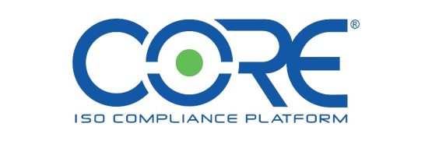
Our Approach: We have determined which internal and external documented information (7.5) is necessary for the effectiveness of our quality management system. This documented information is created, approved, and controlled according to applicable requirements primarily through the use of our CORE ISO Compliance Platform®.

SECTION 2: DO
Providing our customers with products and services that meet their requirements and expectations is why we are in business. This takes planning, reviewing, as well as execution of these processes to ensure that all requirements are identified and met.
In this section of the handbook, we will be describing our methods for conforming to the operational planning, requirements determination and review, design and development, purchasing, product and service provision, post-delivery activities, and what we do when something doesn’t go quite as we expected.

8 Operation

8.1 Operational Planning and Control
Requirement: Plan, implement and control the processes needed to meet requirements for products and services and to implement the actions determined in 6.1, by:
- determining requirements for the product and services;
- establishing criteria for the processes and for the acceptance of products and services;
- determining the resources needed to achieve conformity to product and service requirements;
- implementing control of the processes in accordance with the criteria;
- maintaining and retaining documented information to the extent necessary to have confidence that the processes have been carried out as planned and to demonstrate conformity of products and services to requirements.
The output of this planning is suitable for the organization's operations.
Our Approach: The processes, including outsourced processes that affect our products and services are controlled (8.1). The details and evidence of our processes are maintained within the QMS Plan and Process Plans. All planned changes are controlled, un-planned changes are reviewed and actions to mitigate are taken for any adverse effects.

8.2.1 Customer communication
Requirement: Communication with customers includes:
- information relating to products and services;
- inquiries, contracts or order handling, including changes;
- obtaining customer feedback relating to products and services, including customer complaints;
- the handling or controlling of customer property, if applicable;
- specific requirements for contingency actions, when relevant.
Our Approach: Open, and efficient communication with our customers (8.2.1) is very important for communicating information relevant to products and services, contract information, customer complaints, changes, property, requirements and contingency actions.

8.2.2 Determining the requirements for products and services
Requirement: When determining the requirements for the products and services to be offered to customers, ensure that:
- the requirements for the products and services are defined, including; applicable statutory and regulatory requirements, and those considered necessary;
- the organization has the ability to meet the claims for the products and services offered.
Our Approach: Through the use of industry expertise, market studies, historic data and educational conferences, we determine the requirements (8.2.2) for our current or new products and services to ensure that all applicable customer, organizational, regulatory and statutory requirements are identified to ensure that we have the ability to meet the claims and requirements.

8.2.3 Review of the requirements for products and services
Requirement: Ensure that the ability to meet the requirements for products and services to be offered to customers is present. Conduct a review before committing to supply products and services to a customer, to include:
- customer requirements, including requirements for delivery and post-delivery activities;
- requirements not stated by the customer, but necessary for the customers' specified or intended use, when known;
- requirements specified by us;
- statutory and regulatory requirements applicable to the products and services;
- contract or order requirements differing from those previously expressed.
Ensure that contract or order requirements differing from those previously defined are resolved.
Our Approach: After the requirements are determined, the CFO or designee reviews all requirements (8.2.3) to ensure that we have the ability to meet the product and service requirements prior to offering the product or service. If our customer does not provide us with any requirements, we will confirm requirements prior to acceptance. Requirements generated from the product or service, the organization, statutory, regulatory and requirements that are differing from previous ones are reviewed.
Customer requirements are reviewed by CFO or designee and the results are retained in the order file.

8.2.4 Changes to requirements for products and services
Requirement: Ensure relevant documented information is amended and that relevant persons are aware of changes.
Our Approach: When the requirements for products and services are changed (8.2.4), the CFO or designee ensures that relevant documented information is amended and that relevant personnel are made aware of the changed requirements.

8.3 Design and development
Exclusion, see 4.3 above.

8.4 Control of externally provided processes, products and services (Purchasing)
Requirement: Ensure that externally provided processes, products, and services conform to requirements.
Apply controls to externally provided processes, products and services when:
- products and services are provided for incorporation into the organization’s products and services;
- products and services are provided directly to the customer(s) on behalf of the organization;
- a process, or part of a process, is provided as a result of our decision.
Establish and apply criteria for the evaluation, selection, monitoring of performance and re-evaluation of external providers based on their ability to provide processes or products and services in accordance with specified requirements.
Retain documented information of the results of the evaluations, monitoring of the performance and re-evaluations.
Our Approach: We ensure that all of our suppliers of processes, products and services (8.4) conform to all applicable requirements. We apply sufficient controls to any provider of products or services that:
- are directly incorporated into our products or services;
- are provided directly to the customer on our behalf; or
- provide a process, or part of a process requested by us.
Our criteria for selection, evaluation, performance and re-evaluation practices, is described in the table below:

Criteria | Selection | Evaluation/Re-evaluation
Customer specified supplier | X
Project completion |  | X
Technical specifications | X | X
Price and availability | X | X
Product quality | X | X
On time delivery |  | X
Any adverse effect on QMS | X | X

The CFO or designee is responsible for controlling the purchasing process and for maintaining appropriate records. Approved suppliers are listed in our Accounting software. External providers are evaluated during our Management Reviews.
As of the initial release of this document, all current suppliers in good standing are considered to be approved.

8.4.2 Type and extent of control
Requirement: Ensure that externally provided processes, products and services do not adversely affect the ability to consistently deliver conforming products and services to customers by:
- ensuring that externally provided processes remain within the control of the QMS;
- defining both the controls that is intend to be applied to an external provider and those intend to be applied to the resulting output;
- taking into consideration the potential impact of the externally provided processes, products and services on the ability to consistently meet customer and applicable statutory and regulatory requirements; and the effectiveness of the controls by the external provider;
- determining the verification, or other activities, necessary to ensure that the externally provided processes, products and services meet requirements.
Our Approach: The controls (8.4.2) that we decide to apply to our external providers are decided on an individual basis. We ensure all suppliers remain in control our quality management system and apply other controls as necessary by product, service or situation.

8.4.3 Information for external providers
Requirement: Ensure adequate requirements prior to communicating to the external provider, and communicate the requirements for:
- the processes, products and services to be provided;
- approval or release of products and services, methods, processes or equipment;
- competence of personnel, including necessary qualification;
- their interactions with the QMS;
- the control and monitoring of the external provider’s performance to be applied;
- verification or validation activities that the organization, or customers, intend to perform at the external provider’s premises.
Ensure the adequacy of specified requirements prior to communicating to the external provider.
Our Approach: Prior to communicating with suppliers, we ensure that all applicable requirements are clearly identified. These may include requirements relating to products, services, supplier processes, certifications or personnel, and any verification or validation that the supplier provides at their premises.
The purchasing information (8.4.3) is communicated to suppliers via electronic purchase order.

8.5.1 Control of production and service provision
Requirement: Implement controlled conditions, including, as applicable:
- the availability of documented information that defines the characteristics of the products and services, and the results to be achieved;
- monitoring and measurement activities at appropriate stages to verify that criteria for control of processes and process outputs, and acceptance criteria for products and services, have been met.
- the use, and control of suitable infrastructure and process environment;
- the availability and use of suitable monitoring and measuring resources;
- the competence and, where applicable, required qualification of people;
- the validation, and periodic revalidation, of the ability to achieve planned results of any process for production and service provision where the resulting output cannot be verified by subsequent monitoring or measurement;
- the implementation of actions to prevent human error;
- the implementation of products and services release, delivery and post-delivery activities.
Our Approach: We control all phases of our product or service realization (8.5.1). These controls may include; documented characteristics, monitoring and measurement, validations or reviews of products and/or processes, and release and post-delivery activities.
The CFO or designee is responsible for controlling all phases of product and service provision and for maintaining appropriate records.

8.5.2 Identification and traceability
Requirement: Use suitable means to identify outputs when it is necessary to ensure the conformity of products and services. Identify the status of outputs with respect to monitoring and measurement requirements throughout production and service provision. Control the unique identification of the outputs when traceability is a requirement, and retain the documented information necessary to enable traceability.
Our Approach: Where traceability (8.5.2) is a requirement, we use methods suitable to identify outputs to ensure conformity of our products or services. The method(s) used for traceability is determined by the CFO or designee and is accomplished through the use of purchase order numbers.

8.5.3 Property belonging to customers or external providers
Exclusion, see 4.3 above.

8.5.4 Preservation
Requirement: Ensure preservation of process outputs during production and service provision, to the extent necessary to maintain conformity to requirements.
Our Approach: We use methods necessary to ensure that our product or service maintains conformance to the requirements.

8.5.5 Post-delivery activities
Requirement: Meet requirements for post-delivery activities associated with products and services, considering:
- customer requirements;
- the nature, use and intended lifetime of the products and services;
- customer feedback;
- statutory and regulatory requirements;
- the potential, undesired consequences associated with its products and services.
Our Approach: Post-delivery activities (8.5.5) include, product support as applicable, email follow-up, site visits, communication, and are developed considering applicable requirements, product/service use, customer feedback and potential risks.

8.5.6 Control of changes
Requirement: Review and control changes for production or service to the extent necessary to ensure conformity with specified requirements.
Retain documented information describing the results of the review of changes, the personnel authorizing the change, and any necessary actions arising from the review.
Our Approach: Any changes (8.5.6) that occur during our product or service provision are controlled by, communication with the CFO or designee, and recorded within the order records.

8.6 Release of products and services
Requirement: Implement planned arrangements at appropriate stages to verify that product/service requirements have been met.
Release of products/services to the customer does not proceed until the planned arrangements have been satisfactorily completed, unless otherwise approved by a relevant authority and, as applicable, by the customer. Retain documented information on the release of products/services includes:
- evidence of conformity with acceptance criteria
- traceability to the person(s) authorizing the release.
Our Approach: The release of our product/service (8.6) is indicated by means of acceptance of the product and/or service and communication with customer, and does not occur until all planned arrangements have been completed, and is only released by authorized persons.

8.7 Control of nonconforming process outputs, products and services
Requirement: Ensure process outputs that do not conform to requirements are identified and controlled to prevent unintended use or delivery.
Take action based on the nature of the nonconformity and its effect on the conformity of products/services. This applies also to nonconforming products/services detected after delivery of the products or during or after the provision of the service.
As applicable, deal with nonconforming outputs in one or more of the following ways:
- correction;
- segregation, containment, return or suspension of products and services;
- informing the customer;
- obtaining authorization for acceptance under concession.
Where nonconforming outputs are corrected, conformity to the requirements is verified.
Retain documented information that:
- describes the nonconformity;
- describes the actions taken;
- describes any concessions obtained;
- identifies the authority deciding the action in respect of the nonconformity.
Our Approach: Any output that does not conform (8.7) to requirements is identified, and controlled to prevent unintended use or delivery.
We take appropriate action to deal with the nonconformity. Resolutions are described on the Sales Spreadsheet or other documents and/or Corrective Action Form.

SECTION 3: CHECK

We make great efforts to be data-driven decision makers. This can only be accomplished by ensuring that we maintain accurate data and that the data is properly interpreted.
We take the time to analyze data from various areas that supplies us with data on:
- customer satisfaction;
- process effectiveness;
- product/service conformity;
- effectiveness of our QMS;
- external providers;
- our planning efforts;
- external providers; and
- the associated risks and opportunities.
Our thorough “checking” process allows us to have confidence in our quality management system and identify improvement areas.

9 Performance Evaluation

9.1 Monitoring, measurement, analysis and evaluation
Requirement: Determine:
- what needs to be monitored and measured;
- the methods for monitoring, measurement, analysis and evaluation to ensure valid results;
- when the monitoring and measuring will be performed;
- when the results from monitoring and measurement will be analyzed and evaluated. Evaluate the performance and effectiveness of the quality management system through the Management Review process, and retain documented information as evidence of the results.

Our Approach: Our method of monitoring, measurement, analysis and evaluation is maintained within our Measurement Plans. The review of this plan is retained in our Management Review minutes.

9.1.2 Customer satisfaction
Requirement: Monitor customer perceptions of the degree to which their needs and expectations have been fulfilled.
Our Approach: We obtain and, monitor customer perception by means of feedback through emails, conversations and post-delivery follow up. The customer satisfaction data is discussed during Management Reviews.

9.1.3 Analysis and evaluation
Requirement: Analyze and evaluate appropriate data and information arising from monitoring, measurement and other sources to evaluate:
- conformity of products and services;
- the degree of customer satisfaction;
- the performance and effectiveness of the QMS;
- planning implementation;
- the effectiveness of actions taken to address risks and opportunities;
- the performance of external provider(s);
- need or opportunities for improvements to the QMS.
Our Approach: Our sources and evaluations (9.1.3) are described within our Measurement Plans and also retained within our Management Review meeting minutes.

9.2 Internal audit
Requirement: Conduct internal audits at planned intervals to provide information on whether the QMS conforms to requirements, is implemented and maintained.
The organization shall:
- plan, establish, implement and maintain an audit program(s) including the frequency, methods, responsibilities, planning requirements and reporting, which takes into consideration, the importance of the processes concerned, changes affecting on the organization, and the results of previous audits;
- define the audit criteria and scope for each audit;
- select auditors and conduct audits to ensure objectivity and impartiality of the audit process;
- ensure that the results of the audits are reported to relevant management;
- take appropriate correction and corrective actions without undue delay;
- retain documented information as evidence of the implementation of the audit program and audit results.
Our Approach: Our internal audit program is implemented and maintained and is used to ensure that our QMS is maintained and effective. Our internal audits are planned according to importance on our Process Review/Internal Audit Plan. Our auditors are objective and impartial and report the results to management. Auditors are qualified based on completion of an auditor training course or previous experience. Records of this training are maintained by the Management Representative. Corrective Actions resulting from internal audits are taken without undue delay.
The Management Representative is responsible to oversee the internal auditing system and for retaining appropriate documented information. Internal audit results and status are discussed during Management Review.

9.3 Management review
Requirement: Top management conduct planned reviews of the QMS to ensure its suitability, adequacy, effectiveness and alignment with the strategic direction considering:
- the status of actions from previous management reviews;
- changes in external and internal issues that are relevant to the QMS;
- information on the performance and effectiveness of the quality management system, including trends in:
    - customer satisfaction and feedback from relevant interested parties;
    - the extent to which quality objectives have been met;
    - process performance and conformity of products and services;
    - nonconformities and corrective actions;
    - monitoring and measurement results;
    - audit results;
    - the performance of external providers;
    - the adequacy of resources;
    - the effectiveness of actions taken to address risks and opportunities;
    - opportunities for improvement.
The outputs of management review are to include decisions and actions related to:
- opportunities for improvement;
- any need for changes to the quality management system;
- resource needs.
Retain documented information as evidence of the results of management reviews.
Our Approach: Our management reviews are planned, and occur on a quarterly basis at a minimum. These reviews are attended by the majority of
- Top Management
The Management Reviews are planned using a schedule and meeting agenda consisting of all required inputs. The meetings are retained on the Management Review meeting minutes.
Outputs from our Management Reviews include the actions and decisions relating to any opportunities for improvement, needed changes to the QMS and resource needs. Outputs are also retained on the Management Review meeting minutes.

SECTION 4: ACT
This final step within our Plan, Do, Check and Act quality management system serves two purposes. First, it is the step which is used to make the decision of taking or not taking action based on the analysis and evaluations that occur during the “check” step. Whether we decide to take action or not, the decision will always be metric-driven, and risk-based.
The second purpose of the “Act” step is that it serves as the pivoting step that guides our QMS back to the Plan phase to begin the PDCA cycle and support continual improvement.
This last section of our manual covers our approach to improvements and corrective actions.

10 Improvement

10.1 General
Requirement: Determine and select opportunities for improvement and implement actions to meet customer requirements and enhance customer satisfaction, including (as appropriate):
- improving products and services to meet requirements as well as to address future needs and expectations;
- correcting, preventing or reducing undesired effects;
- improving the performance and effectiveness of the quality management system.
Our Approach: We select opportunities relating to:
- improve our products and services;
- correct, prevent or reduce undesired effects;
- improve our QMS.
We retain the documented information regarding improvements on our Measurement Plans and Corrective Action Forms.

10.2 Nonconformity and corrective action
Requirement: When a nonconformity occurs, including those arising from complaints:
- react to the nonconformity, and as applicable:
    - take action to control and correct it;
    - deal with the consequences;
- evaluate the need for action to eliminate the cause(s) of the nonconformity, in order that it does not recur or occur elsewhere:
    - review and analyze the nonconformity;
    - determine the causes of the nonconformity;
    - determine if similar nonconformities exist, or could potentially occur;
- implement any action needed;
- review the effectiveness of any corrective action taken;
- update risks and opportunities determined during planning, if necessary;
- make changes to the quality management system, if necessary.
Corrective actions are appropriate to the effects of the nonconformities encountered.
Retain documented information as evidence of:
- the nature of the nonconformities and any subsequent actions taken;
- the results of any corrective action.
Our Approach: Nonconformities are taken seriously and are reacted to as applicable. We take any actions necessary to ensure that the nonconformity does not recur or occur elsewhere. Nonconformities are documented on our Order Spreadsheet and/or Corrective Action Form and discussed during Management Review.

10.3 Continual improvement
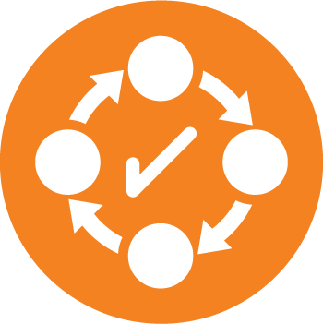
Requirement: Continually improve the suitability, adequacy, and effectiveness of the QMS.
Our Approach: We consider the results of analysis and evaluation, and the outputs from Management Review, to confirm if there are needs or opportunities to be addresses as part of continual improvement.

